Bugzilla and TestLink – Login Page (Form Authentication) test cases

Module Name: Login page (Form Authentication)
Test Case ID: TC008
Tester Name: VIDHI PATEL
Platform: Web application
Test Case Description: To validate the user login and logout workflows on the existing website https://the-internet.herokuapp.com/login (login page) using TestLink for test case management and Bugzilla for defect tracking.
Prerequisites:
- Stable internet connection
- Google Chrome browser
- Valid URL of the login page
- Test user credentials (tomsmith / SuperSecretPassword!)
Environment Information:
- OS: Windows
- System: Laptop (ASUS)
- Browser: Google Chrome
- Webpage: https://the-internet.herokuapp.com/login

Scenario ID: 1
Scenario: login with valid credentials
Test steps:
- Enter valid username: tomsmith
- Enter valid password: SuperSecretPassword!
- Click on Login
Test Input: Valid Username, Valid Password
Expected Result: Redirected to Secure Area page. Message: You logged into a secure area!
Actual Result: Redirected to Secure Area page. Message: You logged into a secure area!
Status: Pass
Comments: Done

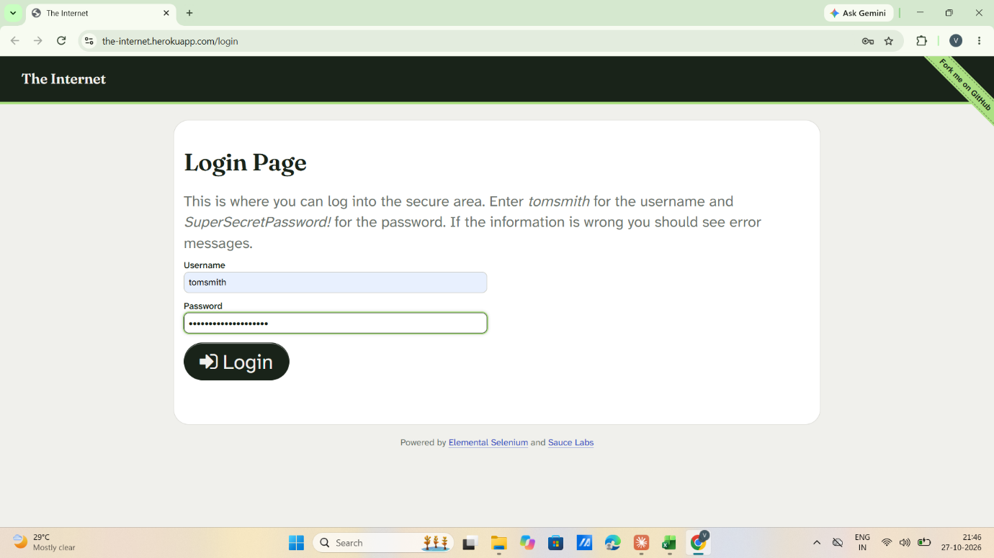

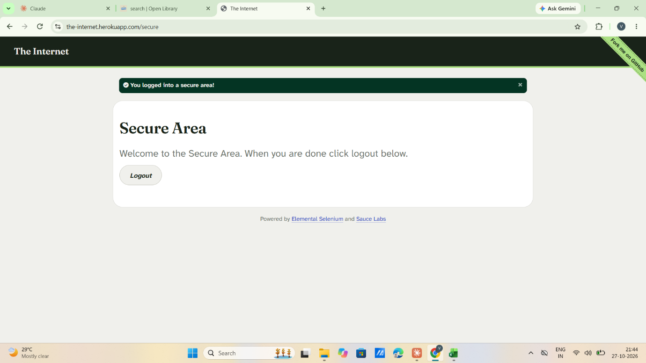

Scenario ID: 2
Scenario: login with invalid username
Test steps:
- Enter invalid username: vidhi patel
- Enter valid password: SuperSecretPassword!
- Click on Login
Test Input: Invalid Username, Valid Password
Expected Result: Should show error: Your username is invalid!
Actual Result: Error displayed: Your username is invalid!
Status: Pass
Comments: Done

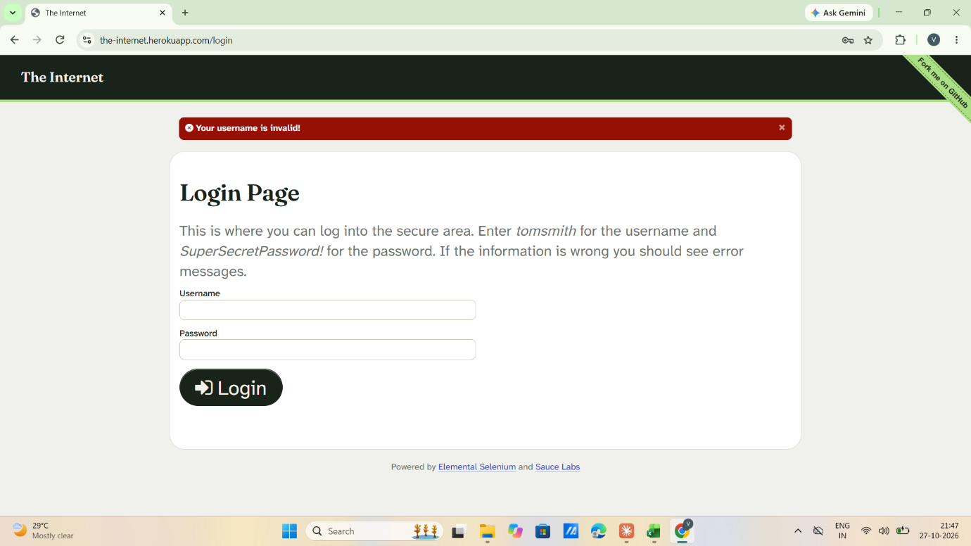

Scenario ID: 3
Scenario: login with invalid password
Test steps:
- Enter valid username: tomsmith
- Enter invalid password: Godisgreat
- Click on Login
Test Input: Valid Username, Invalid Password
Expected Result: Should show error: Your password is invalid!
Actual Result: Error displayed: Your password is invalid!
Status: Pass
Comments: Done

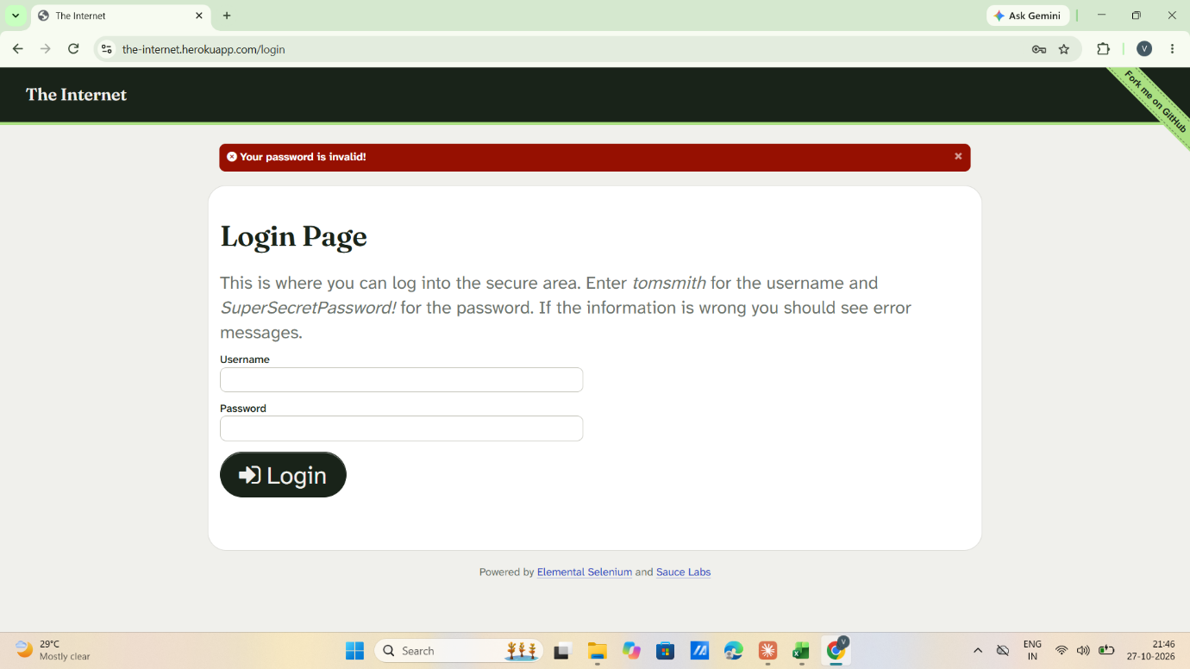

Scenario ID: 4
Scenario: login with invalid username and invalid password
Test steps:
- Enter invalid username: vidhi patel
- Enter invalid password: Godisgreat
- Click on Login
Test Input: Invalid Username, Invalid Password
Expected Result: Should show error: Your username is invalid!
Actual Result: Error displayed: Your username is invalid!
Status: Pass
Comments: Done

Scenario ID: 5
Scenario: login with empty username
Test steps:
- Leave blank at username: -
- Enter valid password: SuperSecretPassword!
- Click on Login
Test Input: Blank Username, Valid Password
Expected Result: Should show field specific error: Username is required
Actual Result: Generic error displayed: Your username is invalid!
Status: Fail
Comments: Defect BUG-001 reported in Bugzilla

Scenario ID: 6
Scenario: login with empty password
Test steps:
- Enter valid username: tomsmith
- Leave blank at password: -
- Click on Login
Test Input: Valid Username, Blank Password
Expected Result: Should show field specific error: Password is required
Actual Result: Generic error displayed: Your password is invalid!
Status: Fail
Comments: Defect BUG-002 reported in Bugzilla

Scenario ID: 7
Scenario: login with empty username and empty password
Test steps:
- Leave blank at username: -
- Leave blank at password: -
- Click on Login
Test Input: Blank Username, Blank Password
Expected Result: Should show error that username and password are required
Actual Result: Generic error displayed: Your username is invalid!
Status: Fail
Comments: Same root cause as BUG-001

Scenario ID: 8
Scenario: logout after successful login
Test steps:
- Login with tomsmith / SuperSecretPassword!
- Click on Logout button on Secure Area page
Test Input: Valid session
Expected Result: Redirected to Login page. Message: You logged out of the secure area!
Actual Result: Redirected to Login page. Message: You logged out of the secure area!
Status: Pass
Comments: Done

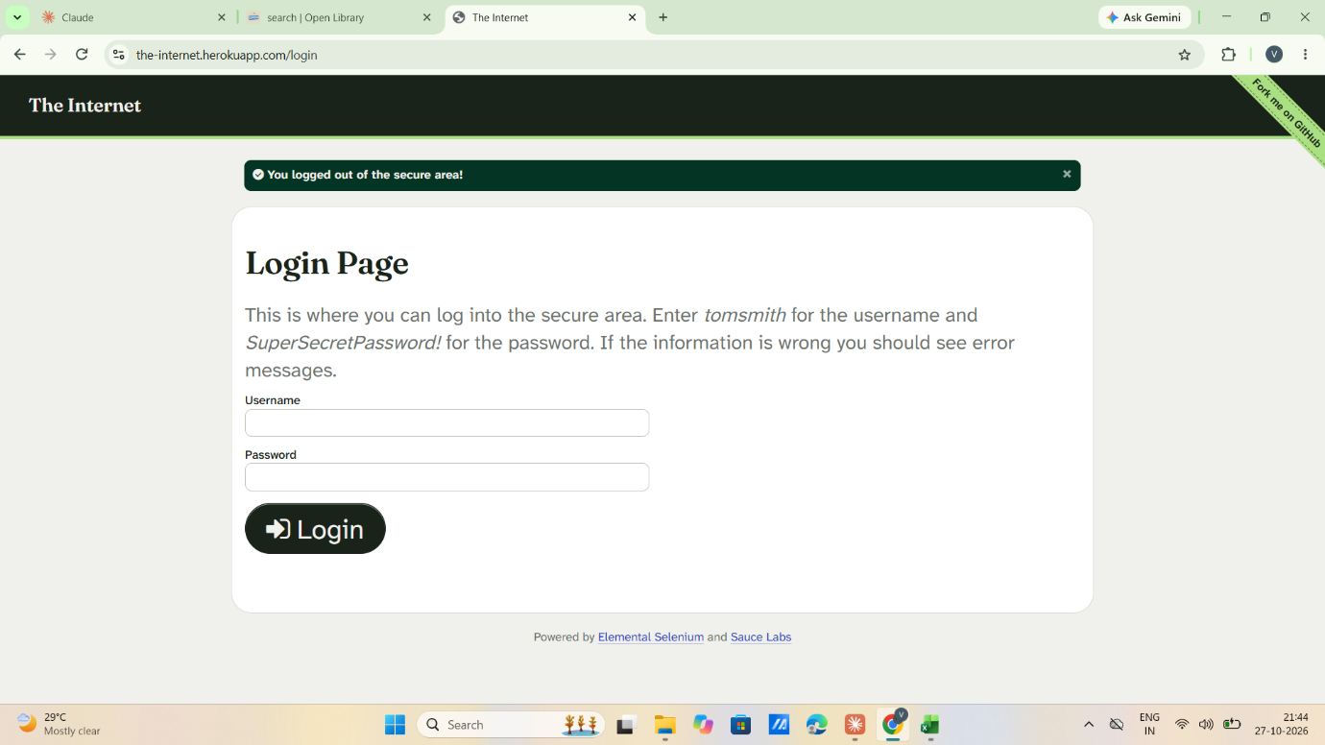

Scenario ID: 9
Scenario: access secure page without login
Test steps:
- Open a new browser tab
- Directly open https://the-internet.herokuapp.com/secure without logging in
Test Input: No login session
Expected Result: Redirected to Login page with error message: You must login to view the secure area!
Actual Result: Redirected to Login page with error message: You must login to view the secure area!
Status: Pass
Comments: Done

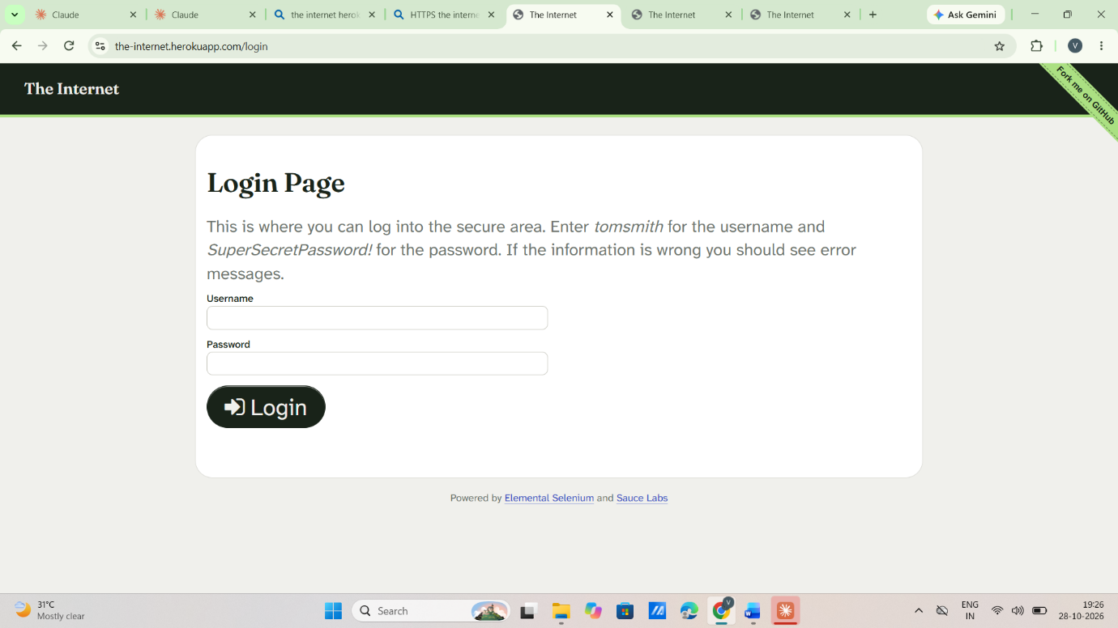

Test Summary Report

Project Name | Website Login Testing (Form Authentication)
Application Tested | https://the-internet.herokuapp.com/login
Module Name | Login Module
Test Management Tool | TestLink (Test Plan: Login Module Testing, Suite: Authentication Testing)
Defect Tracking Tool | Bugzilla
Total Test Cases Designed | 9
Total Test Cases Executed | 9
Total Passed Test Cases | 6
Total Failed Test Cases | 3
Total Blocked Test Cases | 0
Total Not Executed Test Cases | 0
Pass Percentage (%) | 66.67%
Fail Percentage (%) | 33.33%
Overall Test Status | Fail
Tester Name | VIDHI PATEL
Execution Date | 28/10/2026

Test Execution Report

TC ID | Test Scenario | Status | Remarks
TC001 | login with valid credentials | Pass | Done
TC002 | login with invalid username | Pass | Done
TC003 | login with invalid password | Pass | Done
TC004 | login with invalid username and invalid password | Pass | Done
TC005 | login with empty username | Fail | Defect BUG-001 reported in Bugzilla
TC006 | login with empty password | Fail | Defect BUG-002 reported in Bugzilla
TC007 | login with empty username and empty password | Fail | Same root cause as BUG-001
TC008 | logout after successful login | Pass | Done
TC009 | access secure page without login | Pass | Done

Bug Report (Bugzilla)

Bug ID | BUG-001
Product | Login Module (Website Login)
Component | Login Page
Version | 1.0
Severity | Minor
Priority | P3
Summary | Blank username gives generic message "Your username is invalid!" instead of "Username is required"
Steps to Reproduce | 1. Open /login 2. Leave Username blank, enter valid password 3. Click Login
Expected Result | Message: Username is required
Actual Result | Message: Your username is invalid!
Related Test Cases | TC005, TC007
Status | New
Assigned To | Developer

Bug ID | BUG-002
Product | Login Module (Website Login)
Component | Login Page
Version | 1.0
Severity | Minor
Priority | P3
Summary | Blank password gives generic message "Your password is invalid!" instead of "Password is required"
Steps to Reproduce | 1. Open /login 2. Enter valid username, leave Password blank 3. Click Login
Expected Result | Message: Password is required
Actual Result | Message: Your password is invalid!
Related Test Cases | TC006
Status | New
Assigned To | Developer

